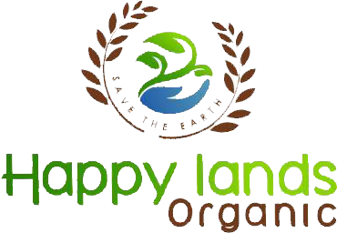

Happy Lands Organic

##### **Franchise Agreement**

Franchise Agreement No :

Date of Agreement :

State/ District/Taluka/Rural Franchise Agreement between Happylands Organic (Franchisor) and …………………………………………………. ( Franchise) Village………………. Taluka…………………. District…………………….. State………………..

Territory :

**RECITALS**

WHEREAS Franchisor has developed a unique system for identifying, Operating and Marketing business offering Organic Agricare, animal Care, Human Care Products, Home care Services Operating under the marks and using the system ( Herein after the “ System” )

WHEREAS Franchisors own the trade name “ Happylands Organic” and related logo’s and Marks and trade dress as more fully described in this agreement (herein after the “Marks” )

WHEREAS, as Between Franchisor and franchisee, Franchisor is the sole ,and exclusive owner of all the good will associated with and to become associated with the marks, the value of franchisee acknowledges.

WHEREAS Franchisee recognizes the advantages and value of the system and marks and desires to obtain a license for a “Happylands Organic” business (Herein after the” Licensed Business” )

WHEREAS Franchise recognizes the necessity and value of maintaining high standards and uniformity of appearance , image, products, services and customer relations in conformity with the system as Franchisor reasonably modify it from time to time;

WHEREAS Franchisee is aware of the risks, business and otherwise, associated with owning an Happylands Organic licensed business and has independently evaluated those risks without relying upon any representations from franchisor and franchisor’s agents regarding revenues, profit Or probability of success, excepting only those representations and accompanying cautions contained in franchisor”s Franchise disclosed documents – revenues or Profits or probability of success being affected primarily by factors beyond franchisors control , including franchisee skill, personality , diligence and dedication and general, regional and local economic and demographical conditions: and

WHEREAS,Franchisor, in reliance upon Franchisees representations is willing to provide certain training and other services and to grant a license, but only on the terms of this agreement , which norms in franchisee understands and accepts and both parties acknowledge to be reasonable and material :

1. First Party : Happylands organic

Signature of authorized signatory :

1. Second Party :

Signature of Franchisee